Go to EC2 INSTANCE ON CONSOLE

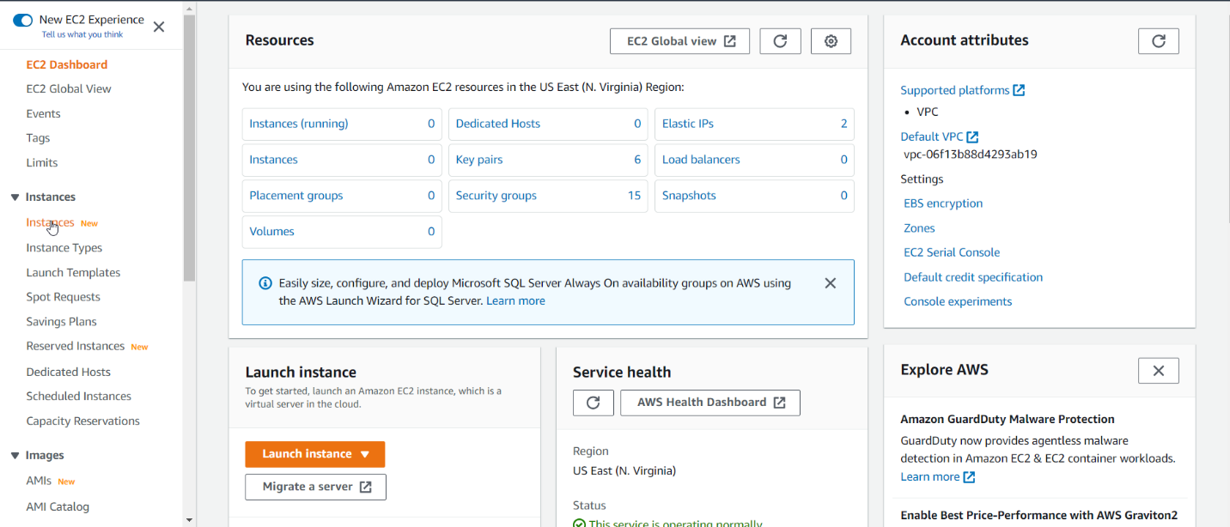

CLICK LAUNCH INSTANCE

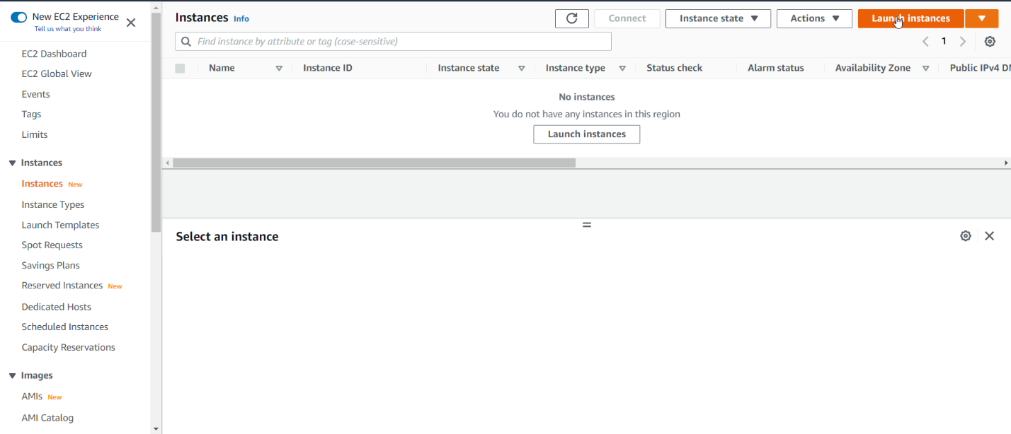

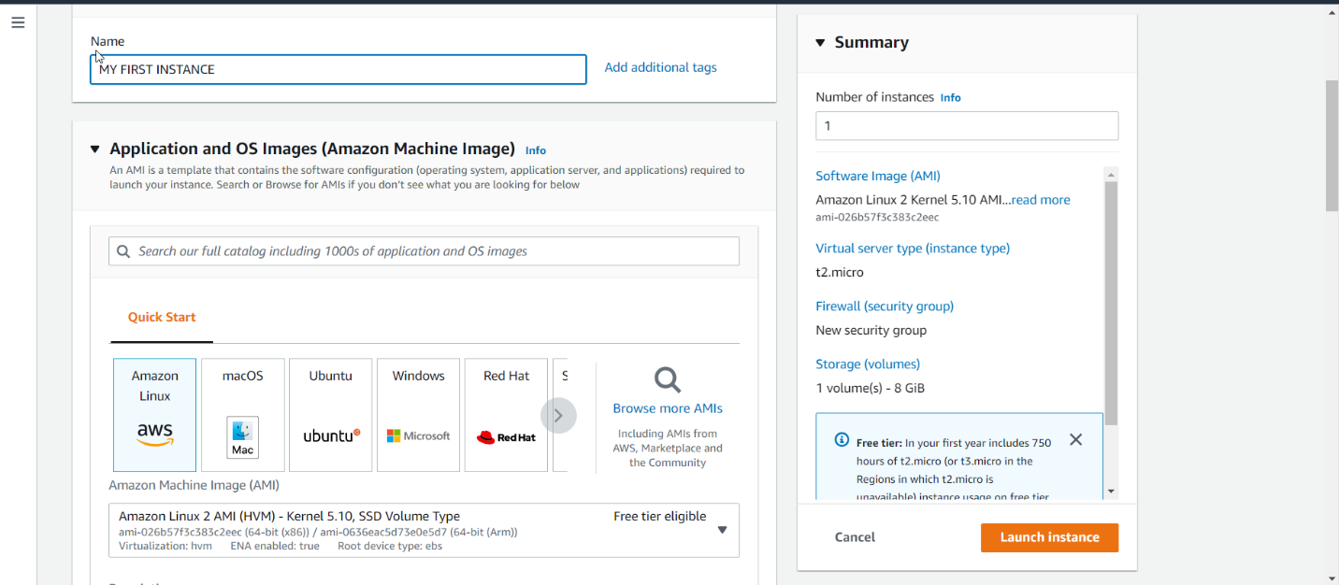

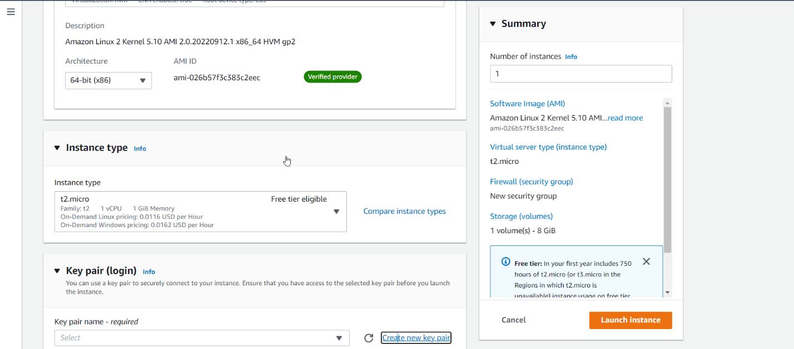

CLICK ON NEW KEY PAIR

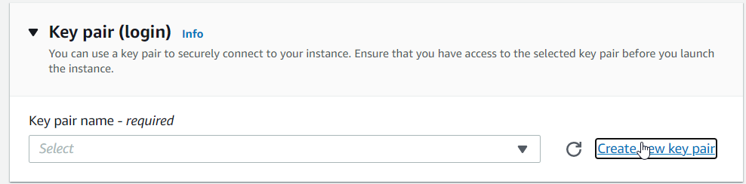

CLICK ON CREATE KEY PAIR

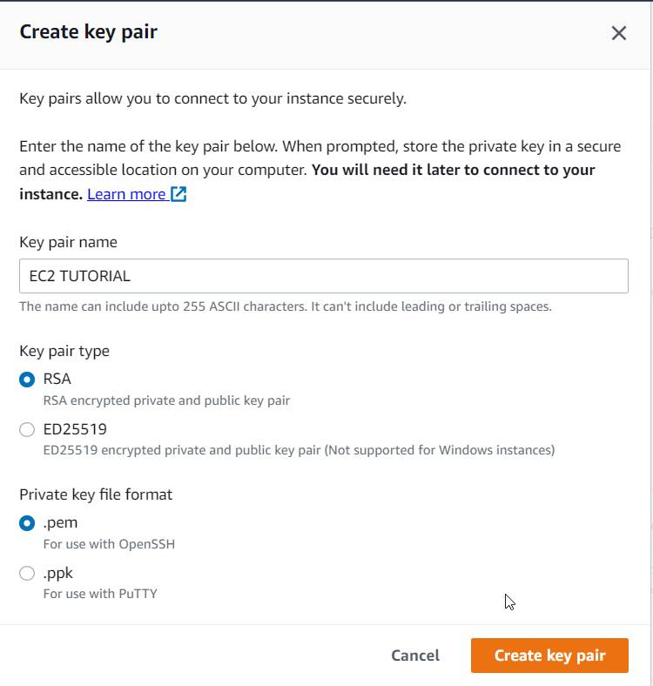

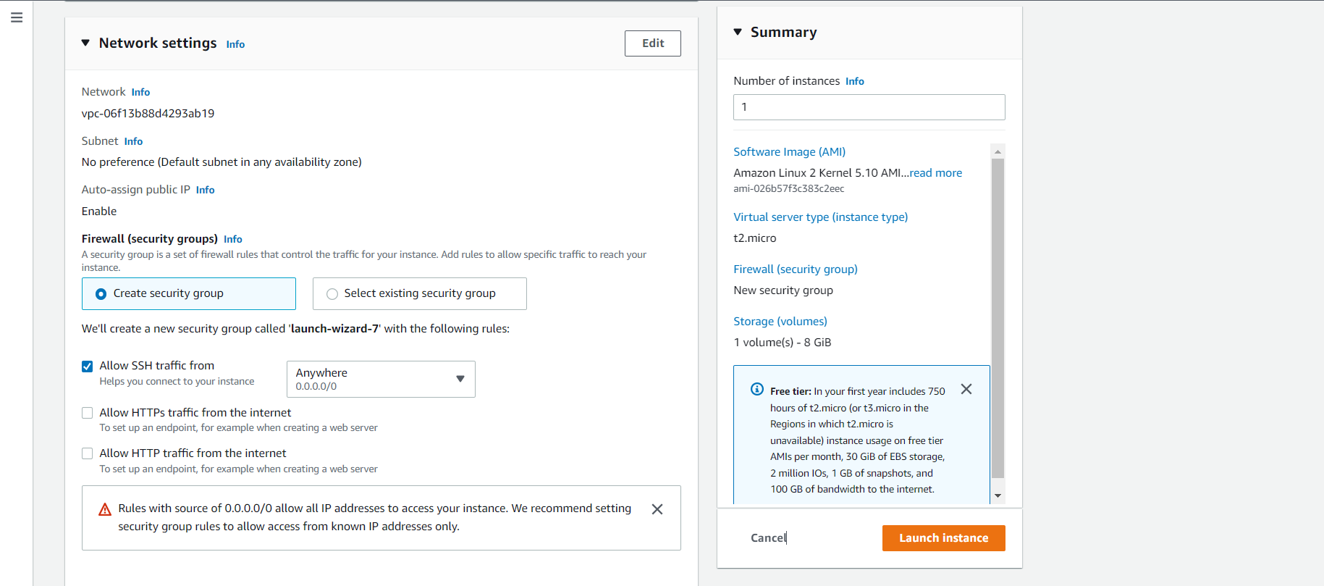

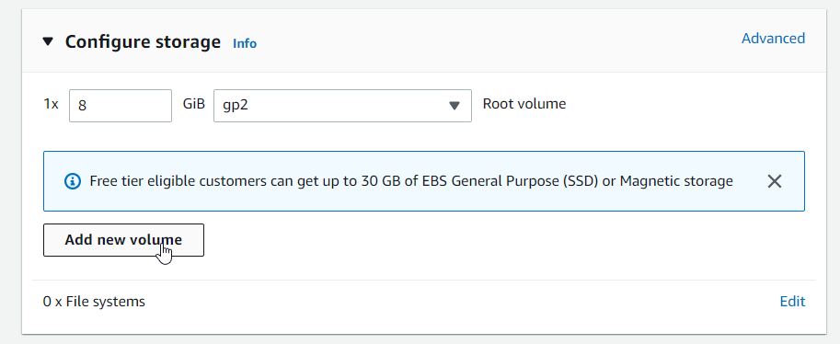

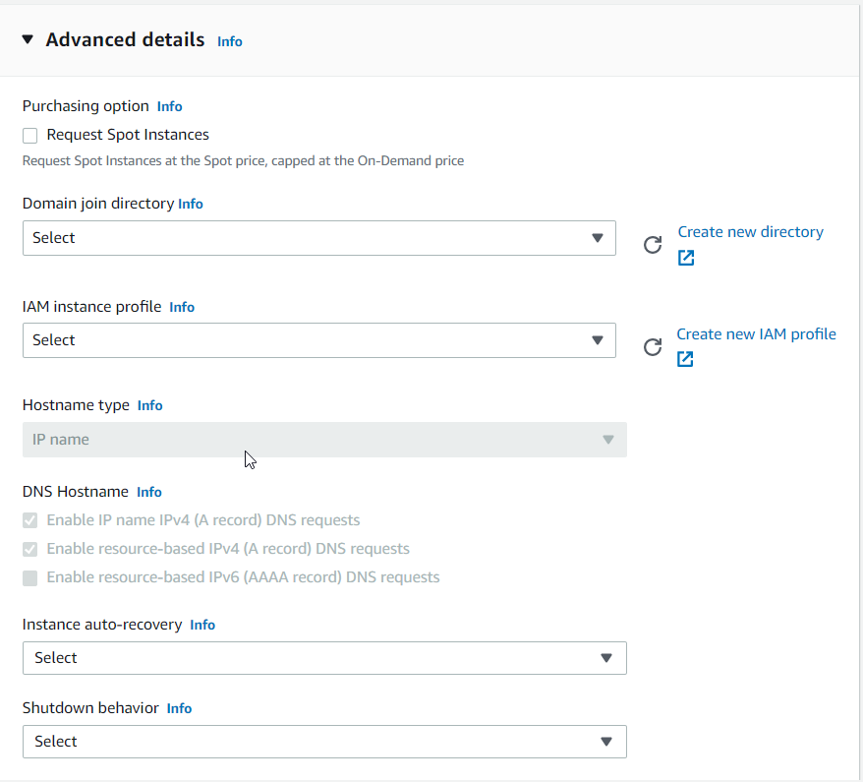

SKIP ALL ON ADVANCE DETAIL

#!/bin/bash

# Use this for your user data (script from top to bottom)

# install httpd (Linux 2 version)

yum update -y

yum install -y httpd

systemctl start httpd

systemctl enable httpd

echo "<h1>Hello World from $(hostname -f)</h1>" > /var/www/html/index.html

Go to user data

Add the following code(if your using ec2 first time)

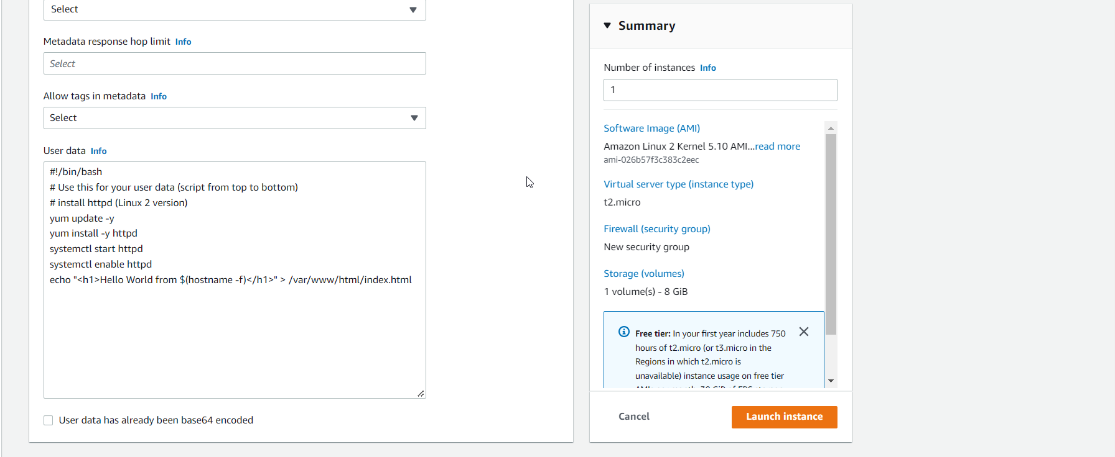

Ec2 instance has been created.

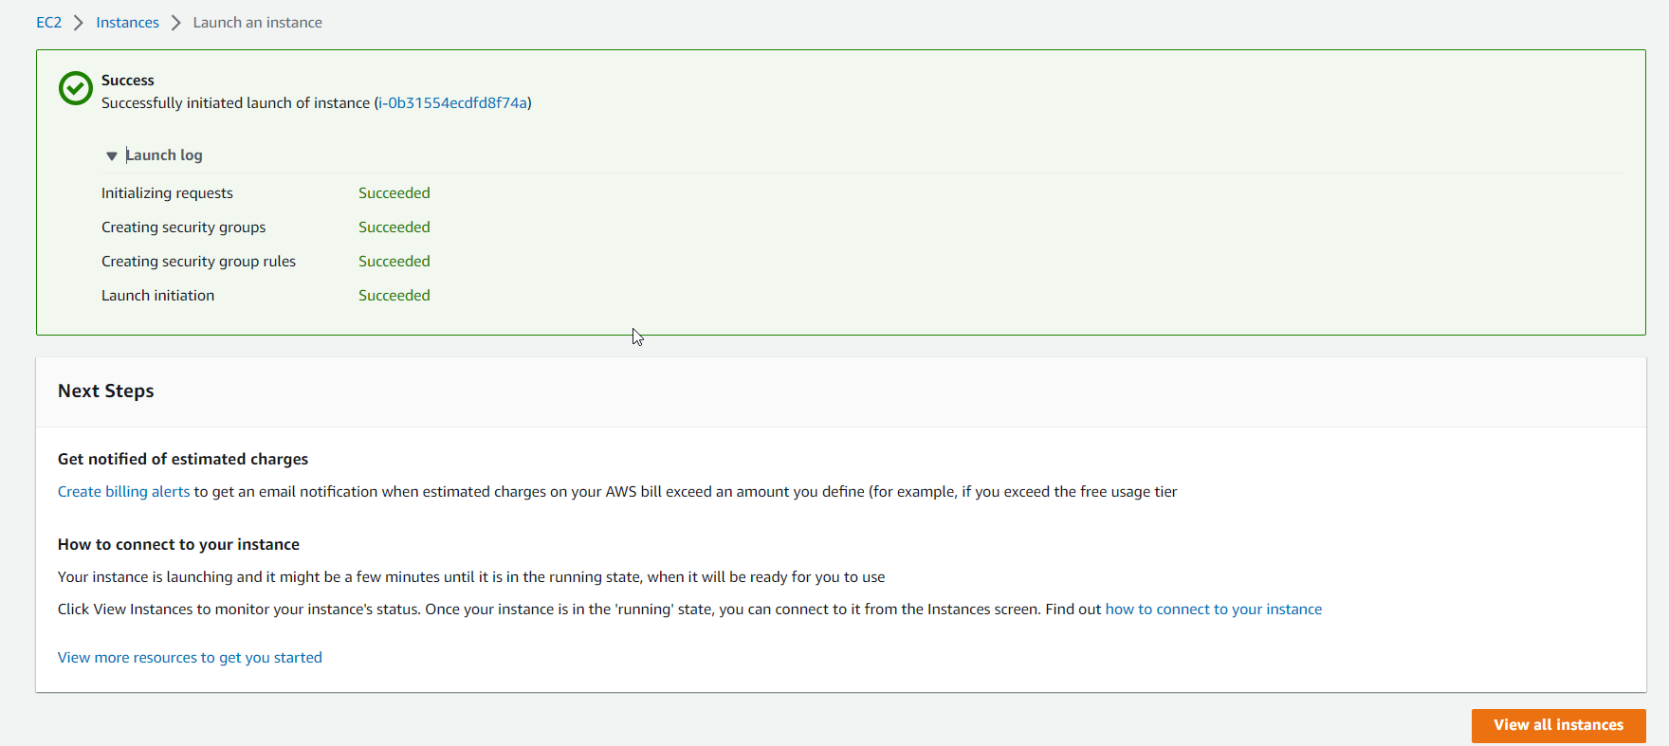

You can see



Stop instance

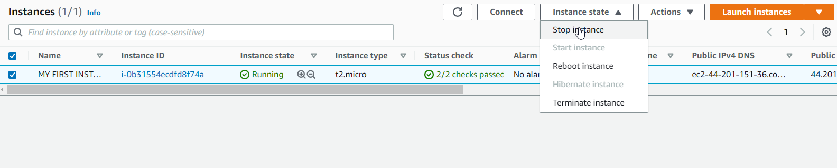

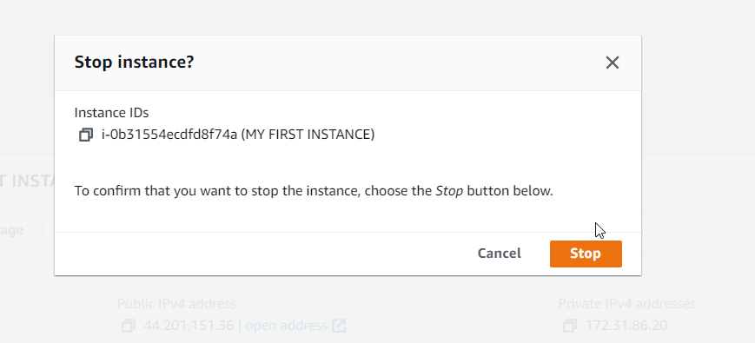

Start instance

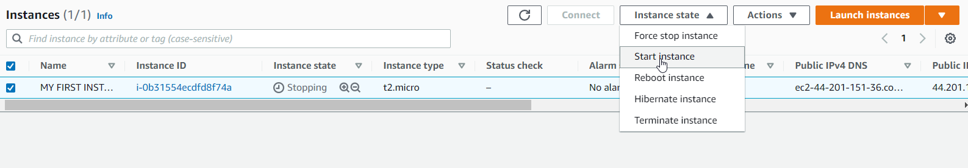

Start instance

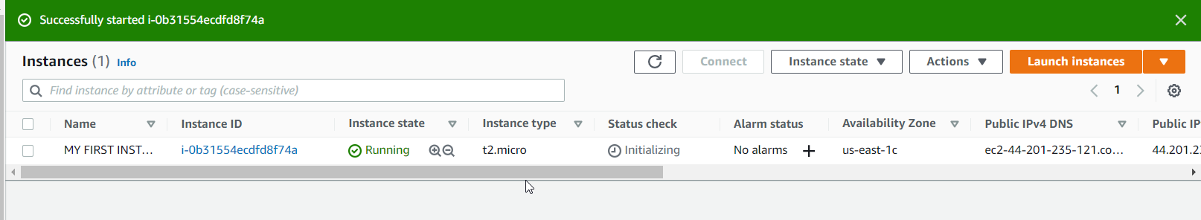

Security Group

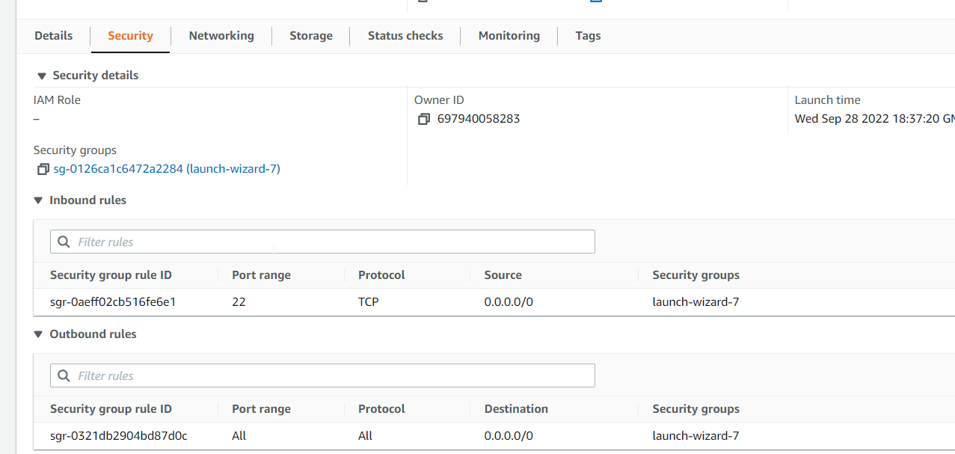

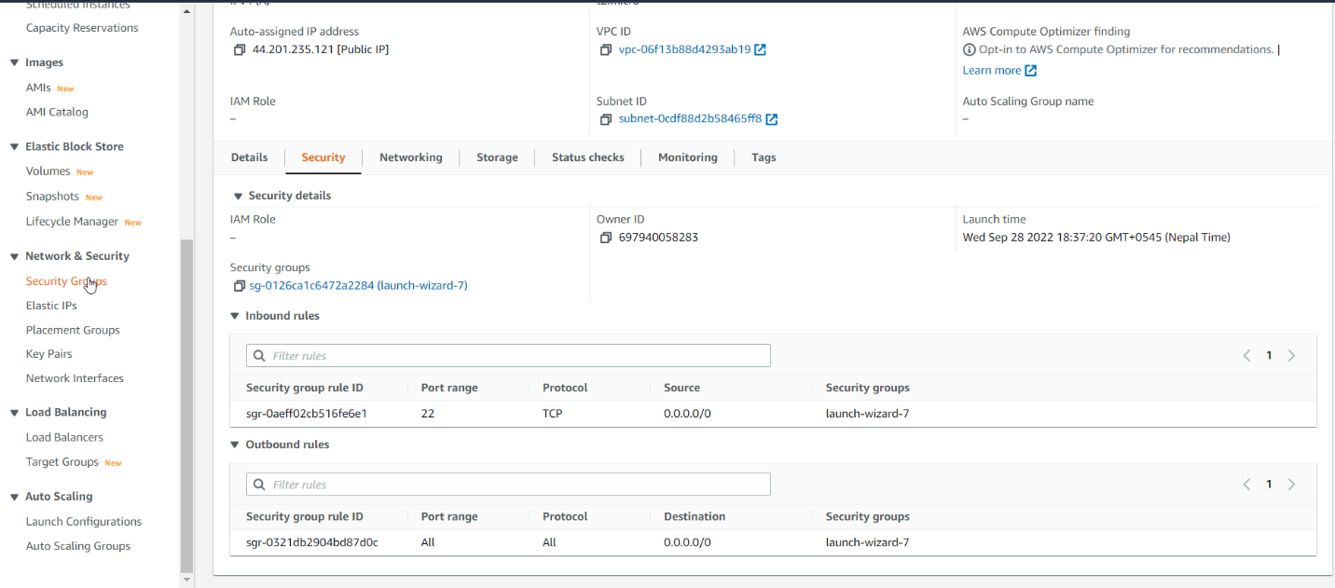

Go to one of security grouo

Go to inbound rules

Click on edit inbound rules

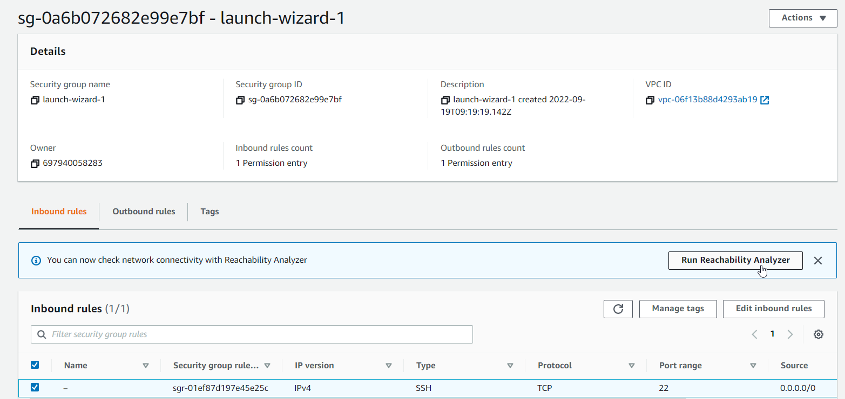

Add http

